NATURAL LANGUAGE PROCESSING
Natural Language Processing is the specialized branch of AI that focuses on interaction between computers and human language. NLP refers to the language used by humas for communication, which includes spoken and written form of communication. The primary goal of NLP is to enable machine to understand, interpret, and generate human like test.

- Reinforcement learning neither comes under supervised learning or unsupervised learning.
LEVELS OF NLP
NLP techniques use different linguistic levels for comprehending and utilizing language, providing an explanatory method for NLP systems.
- Lexical or Morphology: Word formation of Text (language)
- Syntax: Structure of clauses and sentences.
- Semantics: Meaning of various kinds
- Discourse integration: Contextualisation
- Pragmatics: Language use

COMPONENTS OF NLP
- Natural Language Understanding: Interprets the intent behind the input text.
- Dialog Management: Determine the actual context of the dialog and offers state and flow of the dialog to make the conversation human like.
- Natural Language Generator: Focus on the text generation, or the construction of the text.
APPLICATIONS OF NLP
- Sentiment Analysis: It would determine the sentiment expressed in a piece of text.
- Text Classification: It involves categorizing or assigning predefined labels to text documents based on their content.
Here’s an overview of different text representation techniques and models:
a. Count Vectorizer:
- Description: Converts a collection of text documents into a matrix of token counts.
- How it works: Each document is represented as a vector where the value of each position corresponds to the number of occurrences of a specific word.
- Pros: Simple and easy to interpret.
- Cons: Ignores the importance of words in different contexts, high-dimensional and sparse.
b. TF-IDF (Term Frequency - Inverse Document Frequency):
- Description: Adjusts the raw frequency of a term by giving less weight to frequent words and more weight to rare terms.
- How it works:
  - Term Frequency (TF): Measures how frequently a term appears in a document.
  - Inverse Document Frequency (IDF): Measures the importance of a term by down-weighting terms that appear in many documents.
- Pros: More meaningful representation by considering both the frequency and importance of terms.
- Cons: Still sparse, and it does not capture word context or semantic meaning.

c. Word Vectors (Word2Vec, GloVe):
- Description: These are dense, continuous-valued vector representations of words based on their surrounding context.
- How it works:
  - Word2Vec: Uses two architectures (CBOW and Skip-gram) to learn word embeddings by predicting words from their context or predicting context from a word.
  - GloVe (Global Vectors): Builds a co-occurrence matrix and factorizes it to get word vectors.
- Pros: Captures semantic meanings and relationships between words (e.g., king - man + woman = queen).
- Cons: Fixed embeddings for words, context-insensitive.

d. Embeddings (General Term):
- Description: Dense vector representations of text elements (words, phrases, or sentences). Embeddings are learned representations where semantically similar words/phrases have similar vectors.
- How it works: Embeddings map words or tokens into a continuous vector space where similar words are closer to each other.
- Pros: More efficient and expressive compared to sparse vectors.
- Cons: Quality depends on the size and diversity of the training data.

e. Transformer Embeddings (e.g., BERT, GPT):
- Description: Contextualized embeddings that depend on the surrounding words in the sentence, unlike traditional word vectors (e.g., Word2Vec) which are fixed for each word.
- How it works: Transformers generate embeddings by applying attention mechanisms that consider the entire sequence of words in the input, allowing the model to learn word meaning based on context.
  - BERT (Bidirectional Encoder Representations from Transformers): Considers both left and right contexts, creating embeddings specific to each word's role in the sentence.
  - GPT (Generative Pre-trained Transformer): Focuses on left-to-right context for generating language.
- Pros: Captures rich contextual information and polysemy (the same word can have different meanings based on context).
- Cons: High computational cost, complex to train.

- Speech Recognition: Technology that convert spoken language into written text.
- Language Modelling: It involves predicting the probability distribution of a sequence of words in a given language.
- Chatbots and Virtual assistants: Chatbots and Virtual assistants are applications that use NLP and AI technologies to engage in conversation and provide information or perform tasks for users.

NATURAL LANGUAGE PROCESSING MODELS: All these models are pretrained model. With ever increasing data size and the challenges, demand for more efficient and effective NLP models is inevitable
- BERT (Bidirectional Encoder Representations from Transformers): It is a powerful pre-trained NLP model introduced by Google researchers in 2018. It has significantly influenced the field of NLP and set new benchmarks for various language understanding tasks.
- ELMO
- RoBERTa (Robustly optimized BERT approach): It is a variation of the BERT model, introduced by AI research (FAIR) in 2019. RoBERTa aims on addressing some limitations and improving the performance of BERT.
- XLNet: It is a transformer-based language model introduced by Google AI and Carnegie Mellon University researchers in 2019. It also builds upon the architecture of BERT and incorporate additional innovations to overcome some limitations.
- ChatGPT-3: It is a language model developed by OpenAI. It is the third iteration in the GPT series and is known for its impressive language generation capabilities.

CHALLENGES OF NLP
- Ambiguity: Understanding language can be challenging due to the ambiguity of words, which can have multiple meanings. Hence, trying to figure out exactly what someone means is a big challenge of NLP.
- Language Variability: Variation in languages across dialects and accents poses challenge in developing an NLP model. The limited usage of certain languages is also a significant challenge in the implementation of NLP.
- Sarcasm and irony
- Lack of contextual understanding
PYTHON LIBRARIES OF NLP
- Data Manipulation and processing: NumPy and python
- Data Visualisation: Matplotlib, seaborn, Dash, Plotly
- Deep Learning: Tensorflow, Keras, Pytorch
- Scrapping: BeautifulSoup (bs4), Requests, Scarpy, Selenium, LXML, Pyppeteer
- ML Operations: MLflow
- NLP: NLTK, spaCy, TextBlob, Transformers (By Hugging face), Gensim, Flair, Polyglot, StanfordNLP, TfidfVectorizer,
- Speech: PyDub, SpeechRecognition, Librosa, PyAudio, TorchAudio, Wave (Stanford Python Library), Noisereduce, Vosk, Deepspeech, OpenSMILE, FFmpeg, SoundFile.
- Deployment: Flask, Django, FastAPI, Streamlit, Dash, Gunicorn, Docker, Heroku, Tensorflow Serving, Kubernetes, MLFlow, Gradio, Flask-RESTful, AWS lambda with Zappa, Google Cloud Function (gcloud CLI).

TEXT PROCESSING: Tokenization, Remove Stopwords, Lemitization and Stemming
Bigram: Analyse 2 tokens
NER Task (Named Entity Recognition): Identify Named entity or Real-world objects. It is very helpful in information extraction. NLP will not be able to identify entities from Domain.
Customized NER: It helped in Information extraction and helped in converting unstructured data to structured data.

TEXT DATA ANALYSIS
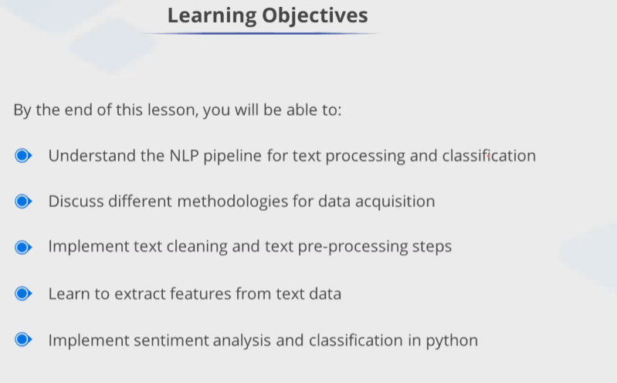
NLP Pipeline: It is a sequence of processing steps that are applied to a text document to extract useful information and insights.
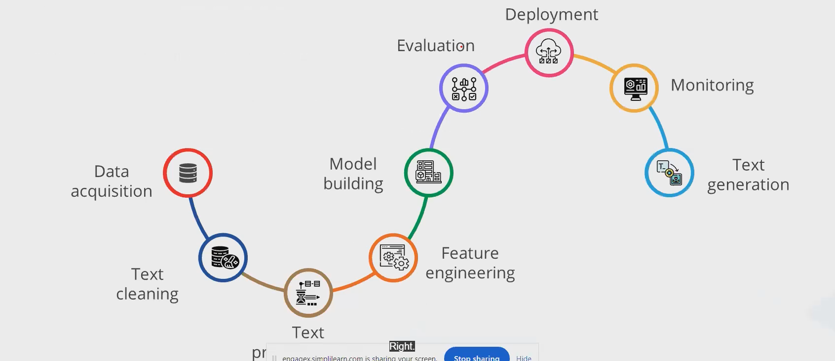
DATA ACQUISTION: Data is present in pdf. So, we can extract the data from pdf through pypdf library. Text data acquisition involves the systematic collection of textual information from various sources. Text data can be acquired in following ways:

    - Web Scrapping
    - Application Programming Interfaces (APIs): APIs play a crucial role in text data acquisition, providing structured access to information from various sources. APIs enable developers to programmatically retrieve textual information from various sources. Online services like Google, and Twitter offer such APIs for retrieval textual information from these platforms.
    - Pdf to text
    - Data Augmentation: Refers to the process of artificially expanding a dataset by generating diverse variations of existing textual data. Data augmentation technique aims to improve the robustness and generalization of machine learning models. Commonly used techniques include text synonym, replacement, and random swap, among others.
    - Image to text: Computer vision and Optical character recognition are used to extract texts content present in images. Tesseract library from Python utilizes OCR technology to convert images into textual data.

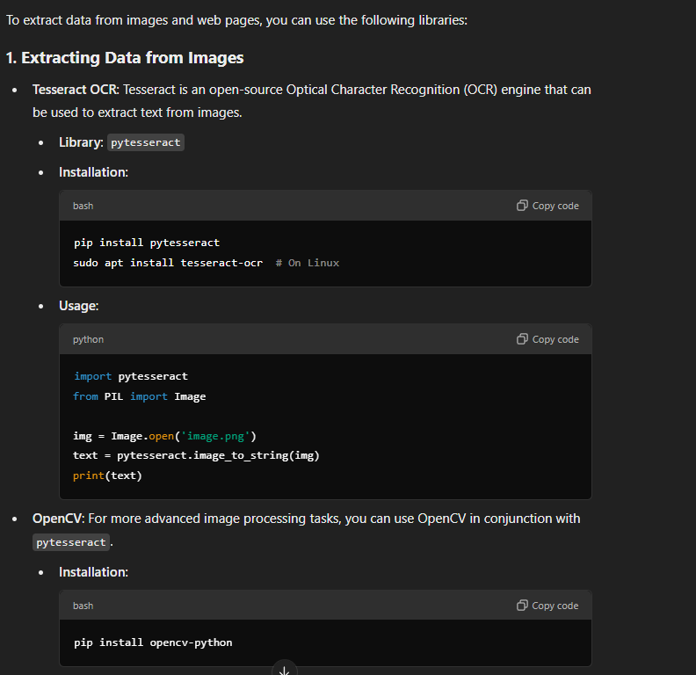

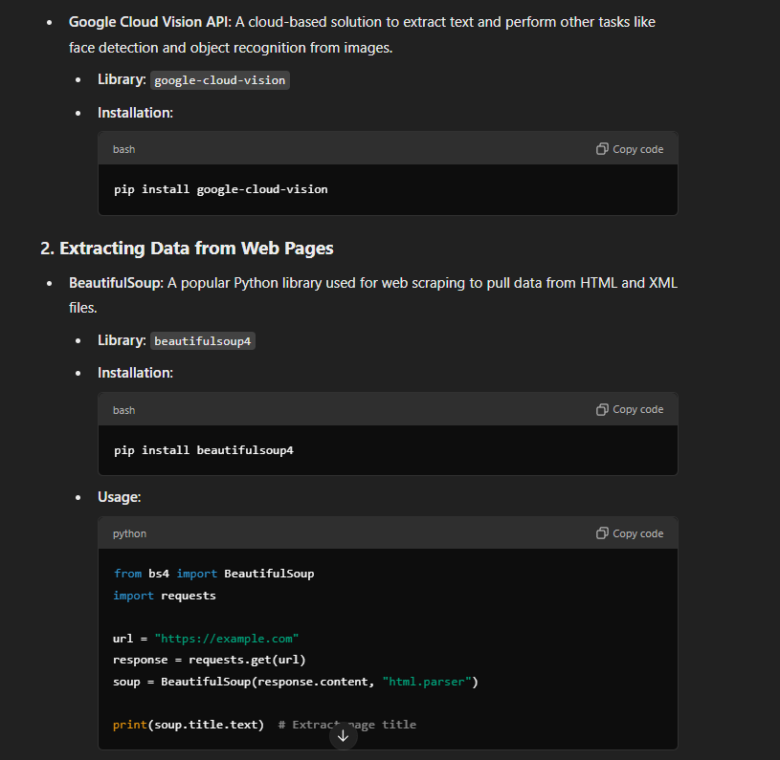

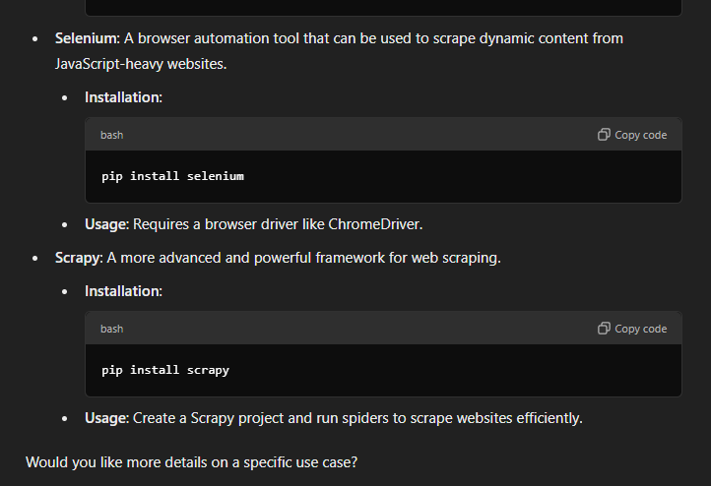

TEXT CLEANING AND PRE-PROCESSING
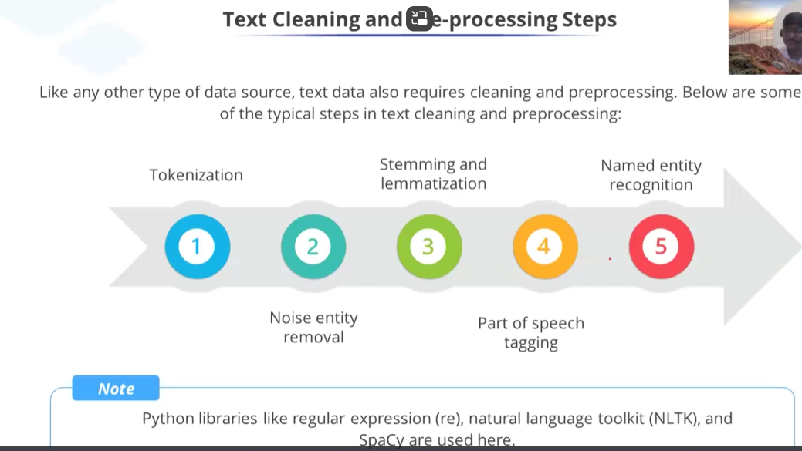

Tokenization: It involves segmenting unstructured data into natural language text into distinct units or elements, shaping the foundation for further analysis.
For example: 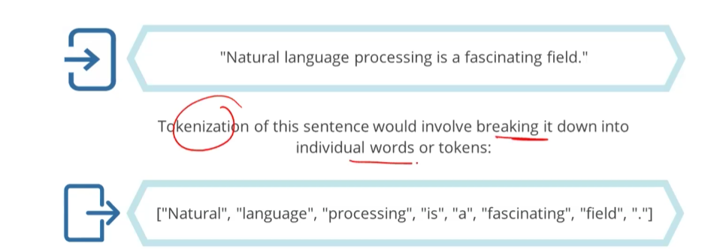

Text Cleaning: The text data contains lot of noise. These entities don’t contribute any value to the analysis and therefore should be removed from the text. These noise entities include:
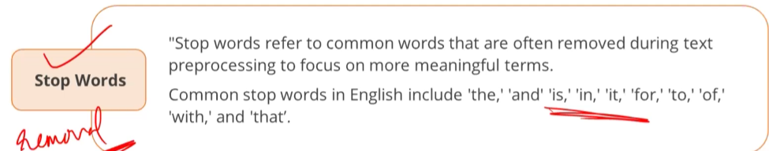
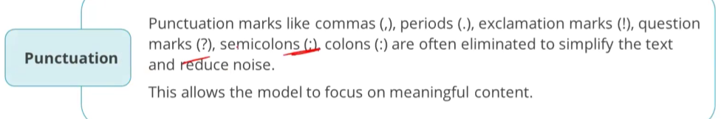
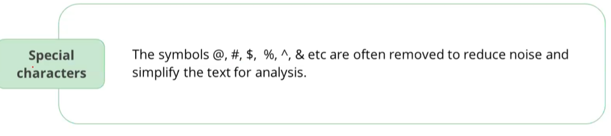
Stemming and Lemmatization: It serves to simplify text by reducing words to their fundamental forms aiding in the reduction of vocabulary size.
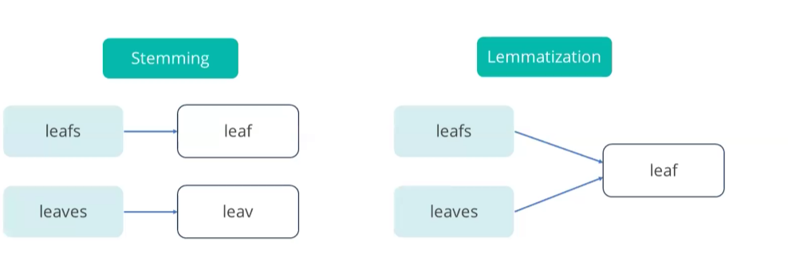
In lemmatization it converts into dictionary form which is more meaningful, but stemming only cuts the words like leaves to leav. Advantage of stemming is that it is faster than lemmatization. The main idea is to identify the root words.
Stemming refers to the straightforward heuristic approach that shortens word endings with the goal of achieving accurate results most of the time, often involving the removal of derivational affixes. For example,
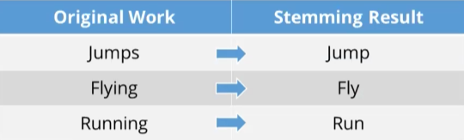
Stemming operation can be performed using several algorithms. The most use algorithms include:
  - Porter Stemmer: It was introduced in 1980 and stand out as one of the most widely adopted stemming method. Its approach revolves around the concept that English language suffixes consist of combinations of smaller, simpler suffixes. It is renowned for its speed and simplicity; it remains a popular choice in various applications.
LEMMATIZATION: It involves reducing words to their basic form by utilizing vocabulary and morphological analysis, with the goal of returning the base or dictionary form of word, referred to as lemma.
- WordNet Lemmatizer (NLTK): An early and extensively utilized lemmatizer leveraging a vast, freely accessible lexical database for the English language.
- TextBlob Lemmatizer: A robust, speedy and user-friendly NLP package that internally employs WordNet for lemmatization.

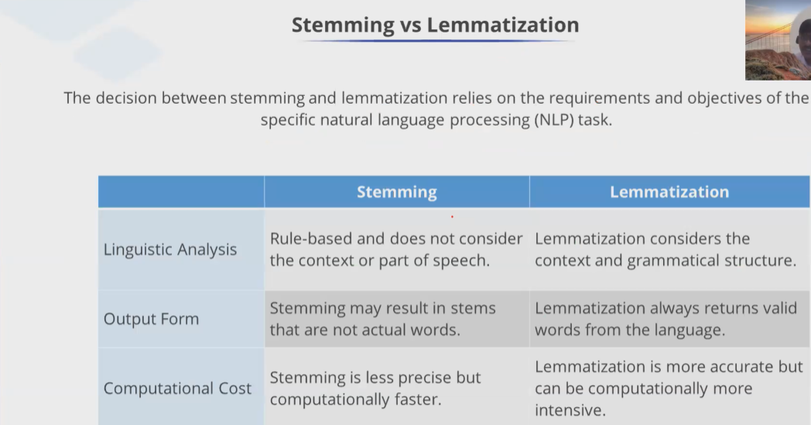

PARTS OF SPEECH TAGGING
Parts of Speech Tagging provides essential information about the syntactic and semantic characteristics of words in any given text, enabling more accurate language understanding and processing.
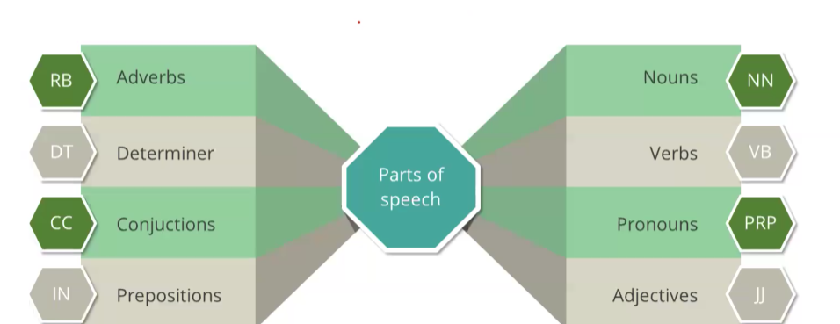
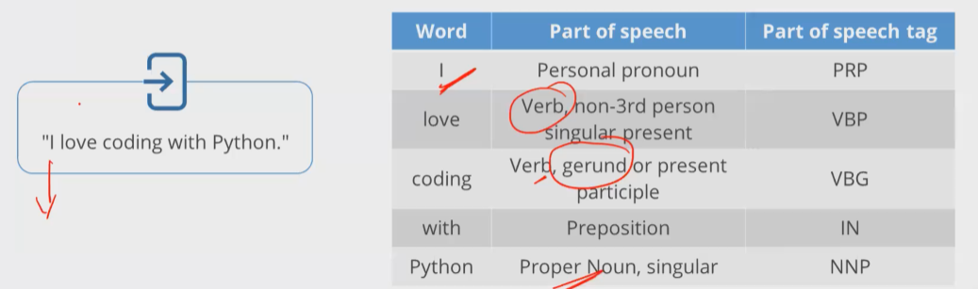

NAMED ENTITY RECOGNITION: NER is like a detective for finding and sorting important things in text. It looks for specific type of things, such as name of an organization, people, places and more.
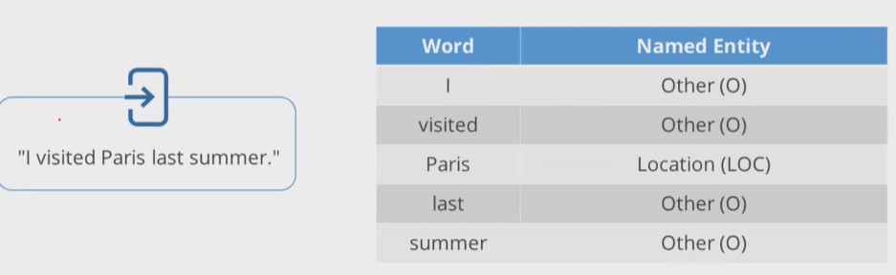

Vocabulary and Feature Extraction: In NLP, vocabulary and feature extraction are fundamental aspects of transforming raw text data into a format suitable for machine learning models.
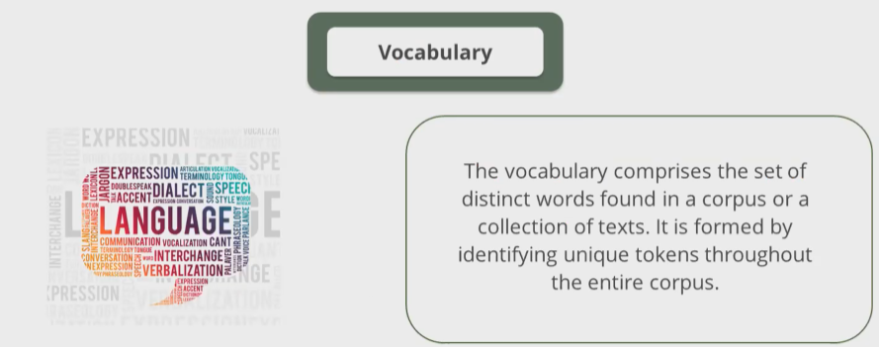
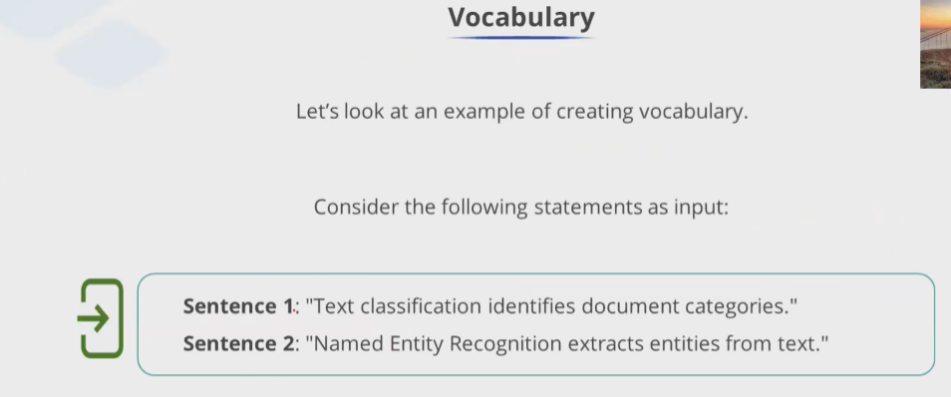

FEATURE EXTRACTION: Text data is inherently unstructured, necessitating conversion into a numerical format for use in machine learning models. The foundational methods which are used to create features from text data include:
    - Fundamental sparse matrix
    - Positive and negative frequencies
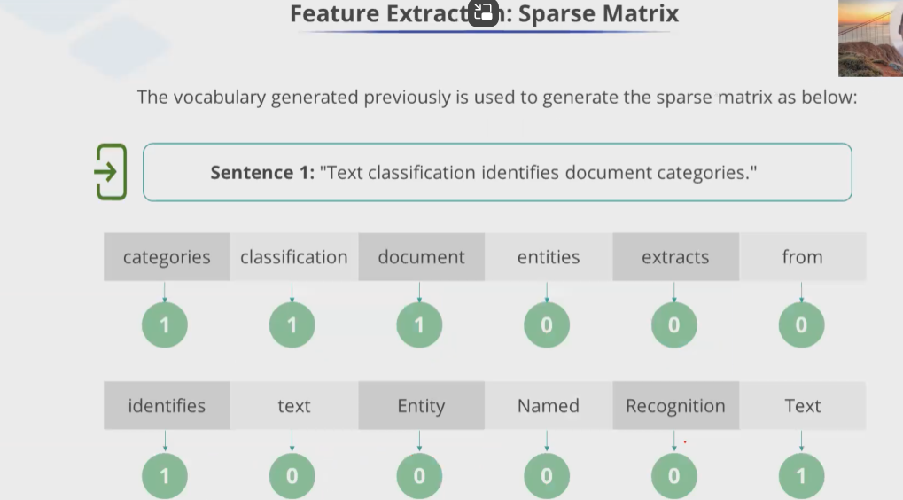
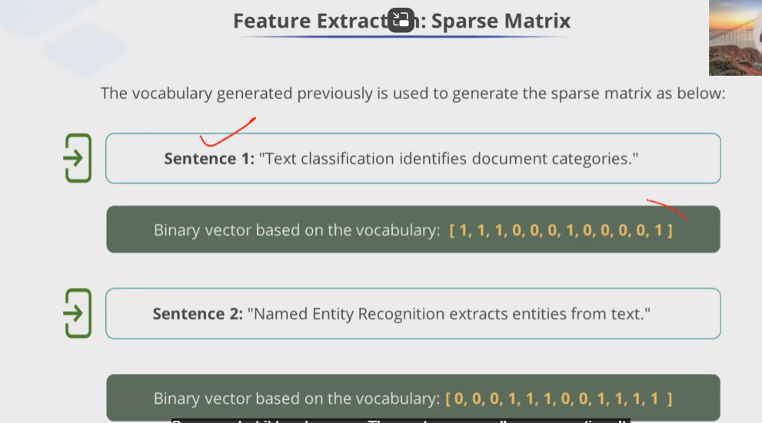
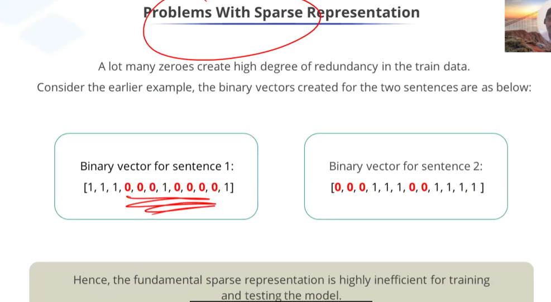
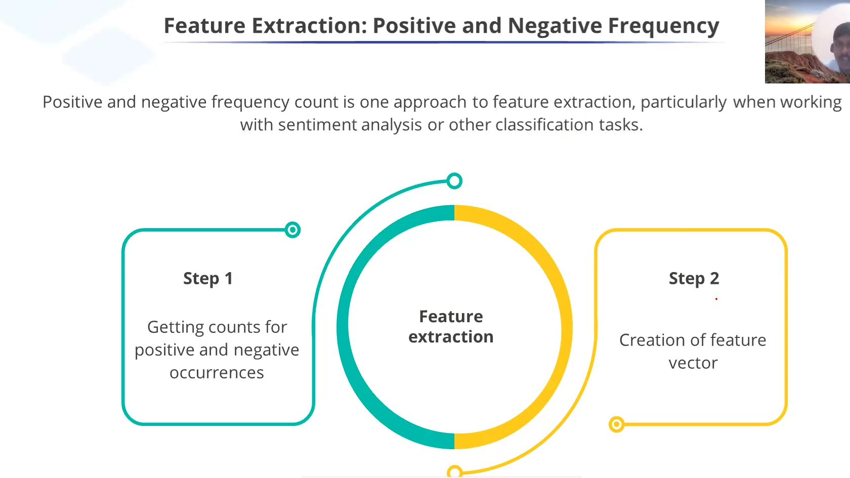
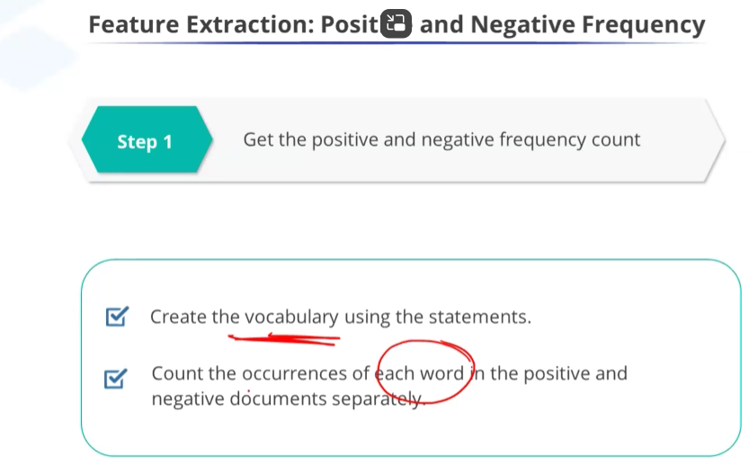
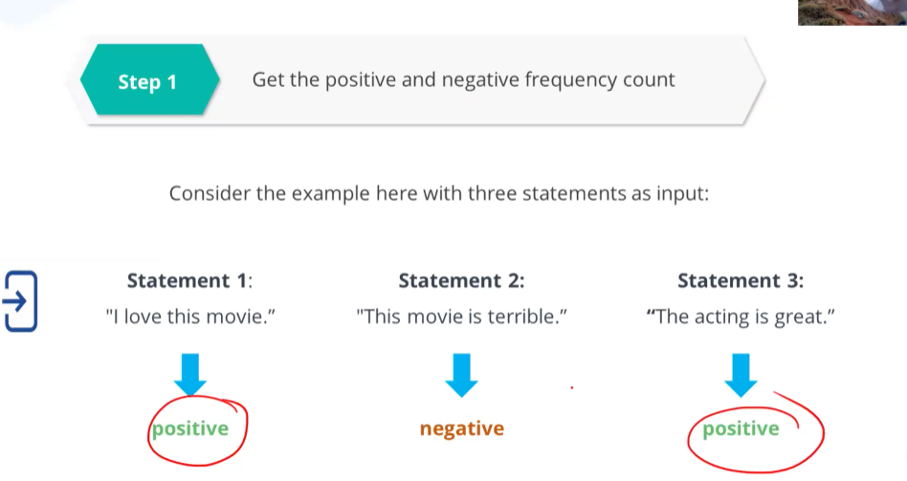
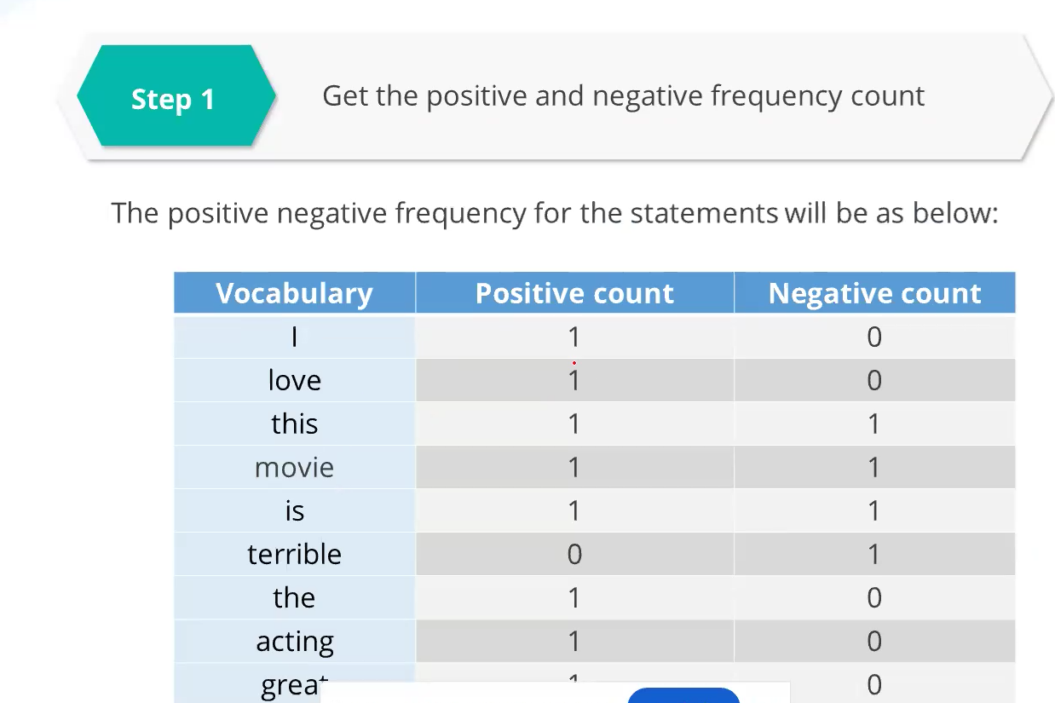
- The most popular feature representation is the space vector.

REVISITING SENTIMENT ANALYSIS
Sentiment analysis is also known as opinion mining, is the process of determining and extracting the sentiment or emotion tone expressed in a piece of text, such as review, social media post, or comment. The goal is to understand whether the expressed sentiment is positive, negative or neutral.
Python provides various functions in different libraries for performing sentiment classification. These include:
    - NLTK (Naïve Bayes Classifier)
    - TextBlob sentiment analyzer
    - Vader sentiment analysis
    - Flair: text sentiment classifier
- Building an NLP model is nothing but creating an Feature representation plus building an ML model.
numerical form by counting the occurrences of each word in the text. This numerical representation can then be used in machine learning models for text analysis tasks, such as classification, clustering, and sentiment analysis.
How it works:
- Tokenization: Splits the text into individual words (tokens).
- Vocabulary Building: Creates a vocabulary of all the unique words across the text corpus.
- Word Count: For each document (sentence, paragraph, etc.), it counts how many times each word from the vocabulary appears.
Example:
Suppose you have two documents:
- Doc 1: "I love NLP"
- Doc 2: "NLP is fun"
The Count Vectorizer will:
- Create a vocabulary: {‘I’, ‘love’, ‘NLP’, ‘is’, ‘fun’}
- Convert each document into a vector of word counts:
  - Doc 1: [1, 1, 1, 0, 0] (1 ‘I’, 1 ‘love’, 1 ‘NLP’, 0 ‘is’, 0 ‘fun’)
  - Doc 2: [0, 0, 1, 1, 1] (0 ‘I’, 0 ‘love’, 1 ‘NLP’, 1 ‘is’, 1 ‘fun’)
Use Cases:
- Text Classification: Converting text data into features for sentiment analysis, spam detection, etc.
- Topic Modeling: Understanding the prominent topics in a set of documents.
The Count Vectorizer is a simple but effective method for handling text data, and it is widely used for building machine learning models in NLP.

